Effects of Ethnicity and Sex on Life Expectancy in Southeastern North Carolina
University of North Carolina at Pembroke
Ester G. Maynor Honors College
Megan Withrow

May 5, 2022

Abstract
I researched differential mortality among three ethnicities and sexes in Southeastern North Carolina. I identified 13 graveyards and cemeteries with one of the three racial demographics: Native American, Black American or White American. One graveyard was Native American, 4 graveyards were White American and 8 graveyards were Black American. I pooled data from graveyards of the same ethnicity. I analyzed 145 graves in each ethnicity category for a total of 435 observations. I took birth year, death year, and sex from tombstones. I computed age at death by subtraction. I subset the 435 observations into an Immature dataset (individuals of age<5) of 58 observations and an Adult data set of 377 observations. Age at death in Immature individuals was random with no pattern by sex or ethnicity. Adult age at death differed significantly by sex, as females lived longer than males regardless of ethnicity. Adult White Americans lived significantly longer than their Native American counterparts. Black Americans died at intermediate ages that were not statistically different from either White or Native Americans. I suggest several improvements in the research design that would produce better data.

Introduction
I was interested in differential mortality between various ethnicities and sexes in Southeastern North Carolina. Understanding natality and mortality in natural populations has long interested ecologists (Deevey 1947). However, meeting requirements for the creation of lifetables is often difficult (Deevey 1947). Understanding human natality and mortality is also important (Firebaugh et al. 2014). Such information can affect lifestyle decisions such as investments in health and education, as well as account for issues of social inequality (Firebaugh et al. 2014). While I could not discern natality from this study, mortality patterns may be inferred from graveyards in some cases (Smith et al. 1992). Although problems exist for this procedure, it has been used often. Dethlefsen (1979) presented another example of this procedure.
The purpose of this paper is to look at differential mortality patterns between males and females and Black, White, and Native American populations in Southeastern North Carolina.
Methods
Data Collection
I identified graveyards and cemeteries with one of three racial demographics: Native American, Black American or White American. I assumed racial demographics based on the names for most places (i.e., AME Zion churches are Black churches) or by looking at pictures of the congregations. I verbally verified the church or cemetery demographics by asking someone who attended the church or worked at the site. I also asked for permission to take data before continuing. I only considered tombstones of people that were born after 1940 to make the data as current as possible, and I avoided tombstones where I could not determine the sex of the person. Otherwise, I selected the tombstones at random. I recorded birth year, death year, and sex from the tombstones. I selected 145 graves in each ethnicity category for a total of 435 observations in my dataset.
Study Areas
I used 13 graveyards for this study. For some ethnicities, I pooled data over more than one graveyard. Native American data came from a single graveyard, White American data came from 4 graveyards, and Black American data came from 8 graveyards (Table 1).
Data Analysis
I retrieved the following data from the gravestones included in this analysis: date of birth, date of death, and sex. I calculated age at death by subtraction. I entered all the data into a Microsoft Excel spreadsheet. Then, I imported this spreadsheet into Minitab© Statistical software for data analysis. Due to high infant mortality in the data, I created two data subsets: 1. Age at death less than 5 years 2. Age at death 5 years and older. I used the first subset to represent Immature mortality; the sample size was N=58. The second subset represented Adult mortality; the sample size was N=377. I considered immature and adult mortality separately. I analyzed both immature and adult mortality by two-way analysis of variance (ANOVA) with sex and ethnicity as the main effects (Sokal and Rohlf 1995). I analyzed the differences in ethnicity by Tukey’s pair-wise comparisons. For all analyses, I assigned significant differences when P<0.05.

Results
Immature Mortality Dataset
I found no significant differences in immature mortality by sex or ethnicity, and I found no sex by ethnicity interaction (Tables 2, 3). I considered the immature deaths to be completely random, regardless of sex or ethnicity. I conducted no Graphical analysis, as I assigned no significance to the dataset.
Adult Mortality Dataset
I assigned a significant difference in life expectancy based on sex (Tables 4, 5). I determined a significant difference in life expectancy by ethnicity (Tables 4, 5). I found no significance to the sex by ethnicity interaction (Table 4, P=0.527). This last statistical finding is important because it means that life expectancy based on sex is the same regardless of ethnicity and vice versa.
A significant F statistic in ANOVA indicates at least one mean is different from one of the others. Therefore, I performed a Tukey’s pair-wise comparison of the two sex and three ethnicity means (Tables 5, 6). This comparison can specify which of the means are significantly different. The Tukey’s test verified that the two sexes had significantly different ages at death (Table 5, Fig. 1) and that White Americans died at a significantly older age than Native Americans (Table 6, Fig. 2). Black Americans died at intermediate ages that were not significantly different than the other two ethnic groups (Table 6, Fig. 2).

Discussion
I researched differential mortality between various ethnicities and sexes in Southeastern North Carolina. This region uniquely suited my research because of its historically triracial demography. My findings support other research indicating adult females generally live longer than males regardless of ethnicity. Among adults, I found that White Americans lived significantly longer than Native Americans, Black Americans lived to ages between the former two groups. This finding is also in line with other research showing that minorities in America have a significantly reduced life expectancy.
Previous researchers found Native Americans at a higher risk for chronic disease, cancer, and injury than White Americans (Cobb et al. 2014). These higher risks were attributed to social and economic factors, as well as risky behaviors such as tobacco use, lack of physical activity, and cancer screening non-compliance (Cobb et al.2014). Researchers also found disparities in the lifespans of Black and White Americans (Firebaugh et al. 2014). One study attributed these disparities, in part, to less access to health care and health care-coverage for Black Americans when compared to White Americans (Centers for Disease Control and Prevention 2001). This lack of access to adequate health care may be a contributing factor for all minority groups, including Native Americans. Understanding human natality and mortality patterns can account for issues of social inequality, as previously mentioned (Firebaugh et al. 2014). Other studies find Black Americans are at a comparatively higher risk for chronic diseases such as diabetes (Preston et al. 2018). Black Americans were also found to have more variance in their lifespans than White Americans due to heavy mortality among youth (Firebaugh et al. 2014). Homicide was found to contribute greatly to the mortality of Black youths (Centers for Disease Control and Prevention 2001).
While it would have been best if I had produced lifetables for the three groups, my data is insufficient. I provide several reasons for my inability to produce lifetables. I did not restrict date of death. Thus, individuals dying within the last 5-10 years were immature and overrepresented in my sample causing an autocorrelation that prevented their use in the adult data set. A larger data set would probably have revealed greater insight into the ethnicity effect. I could improve my study by increasing the data set size and by limiting data points to individuals whose date of death was at least 70 or so years ago. In addition, I could improve my study by including variance along with length of lifespan (Firebaugh et al. 2014).
Despite these issues, my data shows a clear effect of ethnicity on survivorship. Future research should address this important societal issue and focus on the causes of reduced survivorship in minority populations.

Acknowledgements
I would like to thank the people and institutions that made this work possible. My advisor and mentor Dr. Andrew Ash provided many contributions, as well as personal guidance. Dr. Mary Ash provided manuscript review. Pastors and church members provided information concerning graveyards. Dr. Joshua Busman, Assistant Dean of the Esther G. Maynor Honors College, provided support. Churches allowed access to graveyards. UNC Pembroke and the Esther G. Maynor Honors College provided support and guidance.

Literature Cited
Centers for Disease Control and Prevention. 2001. Influence of homicide on racial disparity in life expectancy-United States, 1998. Morbidity and mortality weekly report 50(36): 780-783.
Cobb N., D. Epsey, and J. King J. 2014. Health behaviors and risk factors among American Indians and Alaska Natives 2000-2010. American Journal of Public Health 104: 481-489.
Deevey Jr, E.S. 1947. Life tables for natural populations of animals. The Quarterly Review of Biology 22(4): 283-314.
Dethlefsen, E.S. 1979. Colonial gravestones and demography. In: Studies in American Historical Demography. NY(NY): Academic Press. P 211-223.
Firebaugh, G., F. Acciai, A.J. Noah, C. Prather, and C. Nau. 2014. Why lifespans are more variable among blacks than among whites in the United States. Demography 51: 2025–2045. Retrieved from 10.1007/s13524-014-0345-2.
Preston, S.H., D. Choi, I.Y. Elo, and A Stokes. 2018. Effect of diabetes on life expectancy in the United States by race and ethnicity. Biodemography & Social Biology 64(2): 139-151.
Smith, G.D., D. Carroll, S. Rankin, and D. Rowan. 1992. Socioeconomic differentials in mortality: evidence from Glasgow graveyards. British Medical Journal 305(6868): 1554-1557.
Sokal, R.R., and F.J. Rohlf. 1995. Biometry. W. H. Freeman Company, New York.

Table 1. Ethnicity and location of graveyards from which I extracted data.
Ethnicity | Data Points | Site | Location
Native American | 145 | Lumbee Memorial Garden | 774 Moss Neck Rd. Lumberton, NC, 28360
White American | 7 | Cumberland Union Baptist Church | 6957 Tabor Church Rd. Fayetteville, NC, 28312
White American | 30 | Cedar Creek Baptist Church | 4170 Tabor Church Rd. Fayetteville, NC, 28312
White American | 59 | Macedonia Baptist Church | 5064 Macedonia Church Rd. Fayetteville, NC, 28312
White American | 49 | Big Rockfish Presbyterian | 4935 Marracco Dr. Hope Mills, NC, 28348
Black American | 11 | Savannah Missionary located at | 6675 Tabor Church Rd. Fayetteville, NC, 28312
Black American | 17 | Chapel Grove AME Zion Church located at | 7951 Tabor Church Rd. Fayetteville, NC, 28312
Black American | 64 | Snow Hill AME Zion Church Cemetery | 204 Snow Hill Church Rd. Mt. Gilead, NC27306
Black American | 3 | Dove Chapel AME Zion Cemetery | 10350 Turnbull Rd. Fayetteville, NC, 28312
Black American | 18 | Carver’s Creek AME Zion Church Cemetery | 210 Carver’s Creek Church Rd. Council, NC, 28434
Black American | 22 | Mount Zion AME Church Cemetery | 3399 Dunn Rd. Eastover, NC, 28312
Black American | 3 | Moore Swamp AME Church Cemetery | 768 Moore`s Swamp Rd. Ivanhoe, NC, 28447
Black American | 7 | Poplar Springs AME Church | 1261 Blackstone Rd. Sanford, NC, 27330
Total | 435

Table 2. Analysis of Variance of age at death for Infants by sex and ethnicity. Statistical significance is assigned for P<0.05
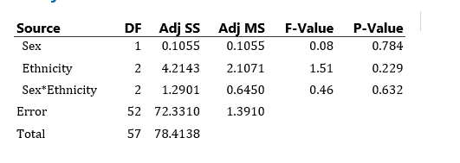

Table 3. Mean age at death for Infants by sex and ethnicity.
F indicates females and M indicates males.
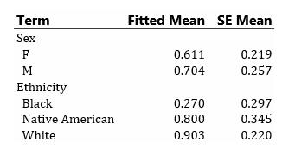

Table 4. Analysis of Variance of mean age at death for Adults by sex and ethnicity. Statistical significance is assigned for P<0.05.
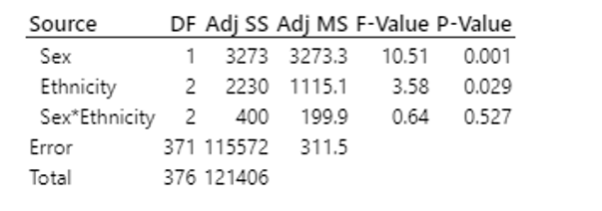

Table 5. Tukey’s multiple comparison for differences in mean Adult age at death by sex. Sexes associated with different letters (A or B) died at significantly different ages regardless of ethnicity. Females died at a significantly older age.
Sex | N | Mean | Grouping
Female | 149 | 48.46 | A
Male | 228 | 42.40 |  | B

Table 6. Tukey’s multiple comparison for differences in mean Adult age at death by ethnicity. Ethnicities associated with different letters (A or B) died at significantly different ages regardless of sex. White Americans died significantly later that Native Americans. Black Americans died at intermediate average age that was not statistically different from either White or Native Americans.
Ethnicity | N | Mean | Grouping
White | 115 | 48.94 | A
Black | 129 | 44.44 | A | B
Native American | 133 | 42.92 |  | B

Figure1. Mean age at death by sex regardless of ethnicity. The two means are significantly different. Females die at a significantly older age.
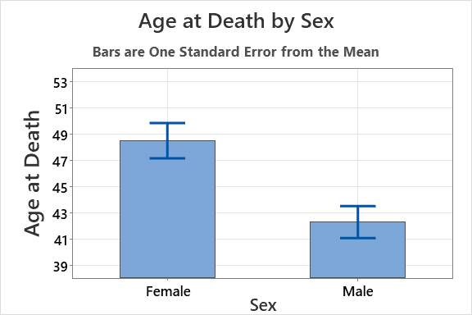

Figure 2. Mean age at death by ethnicity regardless of sex. White Americans die at significantly older ages than Native Americans. Black Americans die at intermediate ages that are not significantly different from either White or Native Americans.
