Measuring value dimensions of IT occupational culture: an exploratory analysis

By: Tim Jacks and Prashant Palvia.

Jacks, T. and Palvia, P. (2014). “Measuring Value Dimensions of IT Occupational Culture: An Exploratory Analysis”. Information Technology and Management. 15 (1), 19-35.
***© Springer Verglag. Reprinted with permission. No further reproduction is authorized without written permission from Springer Verglag. This version of the document is not the version of record. Figures and/or pictures may be missing from this format of the document. ***

The final publication is available at Springer via http://dx.doi.org/10.1007/s10799-013-0170-0

Abstract:

Culture in information systems (IS) research has been an important area of study for over twenty-five years but has focused on two levels of analysis: national and organizational. However, research at the level of IT occupational culture has been minimal. Shared values are the core element of any cultural group and the IS literature has repeatedly called for measurable dimensions of IT culture. This study is an exploratory positivist investigation into scale creation and proposes a set of six value dimensions specific to the context of IT occupational culture based on a review of the relevant IS literature culture as well as interviews with IT professionals. These six dimensions are: Structure of Power, Control, Open Communication, Risk, Reverence for Knowledge, and Enjoyment (abbreviated as SCORRE). A preliminary instrument was prepared and tested with an empirical study. The instrument was found to have both high reliability and construct validity and is ready for further use in ongoing research. There was further evidence that SCORRE represents many core values that form the foundation of IT occupational culture.

Keywords: IT occupational culture | Organizational culture | Alignment | Values | Profession

Article:

1. Introduction

Culture in information systems (IS) research has been an important area of study for over 25 years but has focused on two levels of analysis: national and organizational [15, 30]. However research at the level of occupational culture has been minimal. This study addresses the occupational culture of Information Technology (IT) professionals. IT professionals are defined as people who work within the IT department of an organization, work as freelance IT consultants, or otherwise fulfill the role of IT in supporting hardware, software, and technology services. IT professionals include those who specialize in areas such as Systems Analysis and Design, Programming, Applications Development, Database Administration, Telecommunications, System Administration, Project Management, and Technical Support.

Culture is frequently defined in IS research as “the collective programming of the mind that distinguishes the members of one group or category of people from others” [23, p. 4] which highlights the integration perspective of a cultural group sharing certain values. The integration perspective of culture examines core beliefs that a cultural group has in common, as opposed to a differentiation perspective that looks for differences within a group [28]. Occupational culture, in general, can consist of values, norms, and symbols where values are the most basic beliefs [16]. More specifically, occupational culture arises from shared educational, personal, and work experiences of people in the same occupation who share similar ideologies, speech, and behaviors [5, 53]. For example, in the accounting occupation, accountants are likely to have similar values, interests, and attitudes which mold their perceptions [26]. Similarly, the IT profession has its own occupational culture that is distinct from organizational culture [34, 40, 53]. But Leidner and Kayworth [30] point out that “what has received the least amount of attention in the literature on IT and culture is the very notion of an IT culture” (p. 371). Because the term ‘IT culture’ can be ambiguous between the culture of a particular IT department within an organization and the culture of the entire IT occupation as a whole, this research uses the term ‘IT occupational culture’ to designate the latter. In this sense, IT occupational culture is not bounded by any one organization but rather cuts across all organizations. IT occupational culture, then, can be defined as the values, norms, and symbols shared by those who work in the occupation of IT.

The study of IT occupational culture is important for several reasons. First, culture affects action [48, 51]. Culture has a causal effect on IS behavior at different levels, including national, organizational, and occupational [29]. IT occupational culture, specifically, defines shared meanings and expected behaviors for IT professionals [34]. Second, cultural conflict can arise when two or more groups interact that do not share the same core set of values [30, 34]. Schein [42] defines a group as a collection of people who (1) interact with each other, (2) are psychologically aware of each other, and (3) perceive themselves as a group. Thus, when the IT occupational group interacts with a different occupational group, such as business managers, the result can be cultural conflict [17, 19, 34]. Different occupational cultures are expected to simultaneously interact and conflict with each other [19, 26]. Examining the occupational level of culture is necessary to see why IT departments are so frequently at odds with business users [34] and may help explain the ‘cultural chasm’ that exists between IT personnel and business managers [57]. Moreover, occupational culture may have a greater influence over the performance of work activities than organizational culture [11, 26]. Third, culture in IT departments can impact business outcomes. These outcomes might be positive or negative. For example, IT projects can succeed or fail depending how well departmental IT culture meshes with the business culture of a firm [25, 30, 40, 55]. However, research on IT occupational culture is still in the exploratory stage.

Shared values are the core element of any cultural group [5, 10, 23]. IS literature has repeatedly called for more measurable value dimensions of IT occupational culture [20, 27, 30]. While Hofstede [21] and House et al. [24] have been successful in quantitatively measuring values of both national and organizational culture, this has not been done within the context of occupational culture. Karahanna et al. [29, p. 9] say that “the role of values in attitude models in IS research has been largely ignored, possibly due to the fact that most research was performed in single cultures (both organizational and national).”

A number of gaps exist that this research seeks to fill. First, value dimensions of IT occupational culture are missing in the literature despite being called for [27, 30]. Second, studies of IT occupational culture have so far been interpretive with no quantitative value measures (for example, [20, 27, 34] or quantitative value measures that examine IT culture at different levels of analysis than the occupational (for example, [37, 55]. This study attempts to pinpoint measurable values at the occupational level of analysis that are meaningful specifically within the context of the IT occupation. This study is an exploratory positivist investigation into scale creation in the tradition of Hofstede [21] and House et al. [24] that proposes a preliminary survey instrument to measure the occupational values of the IT occupation. The value dimensions examined are based on a review of the relevant IS literature on culture as well as interviews with IT professionals. The results of both activities informed the creation of a preliminary instrument measuring IT occupational cultural values in order to answer the research question: What are the measurable value dimensions of IT occupational culture? We plan to modify and refine the instrument as part of this ongoing research stream, based on field work and a larger sample, but the preliminary results support further investigation in this area.

2. Literature review

Culture may be broken down into different components according to different frameworks. Ferrante [14] divides culture into material and nonmaterial components. Material components are physical objects to which people have attached meaning while nonmaterial components are intangible and include values, beliefs, and norms [14]. Hofstede and Hofstede [23] divide culture into symbols, heroes, rituals, values, and practices. Schein [42, 43] divides culture into three levels: artifacts, espoused values, and unconscious assumptions, with values being the easiest to identify because they are readily verbalized. Deal and Kennedy [10] discuss values, heroes, rites and rituals, and the environment as elements of culture. Culture can consist of “beliefs, ritual practices, art forms, and ceremonies, as well as informal cultural practices such as language, gossip, stories, and rituals of daily life” [51, p. 273]. Different authors emphasize many different elements of culture including “artifacts, norms, customs, habits, practices, rituals, symbols, categories, codes, ideas, values, discourse, worldviews, ideologies, or principles. And this list is not exhaustive; any list of cultural ‘things’ will necessarily be incomplete” [48, p. 4]. The common element in every cultural framework, however, includes shared values.

Values are shared conceptions of what is good/bad, right/wrong, and important/unimportant with regard to human behavior [14]. Cultural values are the broad goals that members of a cultural group are encouraged to pursue and serve to justify their actions [7]. Values are typically identified as forming the core of any culture [2, 6, 18]. Cultural values are more stable and fundamental than cultural practices because behaviors are based on values [23]. Because values are considered the core of culture, most IS research related to culture at the national and organizational level has focused on value systems [30]. Even when controlling for other key national differences, national cultural values can still be an important predictor of IT product adoptions [3]. For example, Bagchi et al. [4] examined the impact of Schwartz’s espoused values (such as conformity, tradition, and security) on ICT use in different countries and found significant differences as well as similarities between countries. Similarly, Choden et al. [7] examined Schwartz’s values and their impact on Internet Use in developed and developing nations. When measuring cultural values, it is important to note that they are typically measured at the individual level. Srite and Karahanna [49] proposed measuringespoused national cultural values in order to avoid the ecological fallacy of assuming that everyone within a national culture share the same values to the same degree. The same may presumably be said about any level of cultural analysis, hence occupational cultural values, from this point on, refer to espoused occupational cultural values at the individual level.

This exploratory study also attempts to measure a set of values, but at a new unit of analysis, that of the occupation. Occupational culture consists of values, norms, and symbols where values are the most basic beliefs [16]. Trice [53] explores the characteristics of occupational cultures in general, although not in regards to IT specifically. In Trice’s framework, occupational cultures exist apart from organizational culture and can become a source of conflict due to their culture differences [53]. Six characteristics that separate out an occupational culture are identified as (1) Esoteric knowledge and expertise, (2) Extreme or unusual demands, (3) Consciousness of kind, (4) Pervasiveness, (5) Favorable self-image and social value in tasks, (6) Primary reference group, and (7) Abundance of cultural forms [53]. This framework has been used in more recent IS literature to verify that there is, indeed, the existence of such a thing as ‘IT occupational culture’ because it conforms to these six characteristics [19, 20, 40]. For example, esoteric knowledge and technical jargon are prime examples of what separates IT people from other people in an organization. However, the core area of values is absent from Trice’s conceptualization of occupational culture.

Twenty years ago, the idea of IT having its own defined occupational culture was not widely held. Orlikowski and Baroudi [36] asserted that IS is not a ‘profession’ but rather an occupational group. Duliba and Baroudi [12] reinforced that IS personnel form a weak occupational community, if they can be said to form an occupational community at all. In other words, if there is no sense of community, there can be no sense ofshared culture. Twenty years later, the acknowledgement of the existence of IT occupational culture now appears more regularly [15, 17, 34, 56] although research in this area is still nascent.

Three studies in the early 1990s began the work of analyzing IT departmental culture within organizations. First, Pliskin et al. [37] examined the culture of an information system along seven dimensions in a case study of a failed information system implementation. Pliskin et al. [37] selected their seven dimensions of culture based on a review of the most common quantitative measures at the organizational level of analysis. These were (1) Innovation and action orientation, (2) Risk taking, (3) Integration and lateral interdependence, (4) Top management contact, (5) Autonomy in decision making, (6) Performance orientation, and (S7) Reward orientation [37]. Second, Cooper [9] selected two dimensions based on Quinn and Rohrbaugh’s [39] competing values framework of organizational culture. The first axis is control versus flexibility and the second axis is an internal versus external focus. Control refers to organizational order being more important than rapidly responding to change [9]. This early study focused on specific IT practices such as computer-aided instruction, environmental scanning, internal monitoring, and forecasting rather than values [9]. Third, an early attempt to study the shared values of IT culture was Kaarst-Brown and Robey [27]. Five archetypes of IT culture were developed from their ethnographic case study of two organizations using the metaphor of magic to explain differences in IT departmental cultures within firms. The five archetypes include Revered, Controlled, Fearful, Integrated, and Demystified [27] and focus on the relationships between IT departments and business departments. There are advantages and disadvantages to each of the five cultural archetypes which indicate that some IT departmental cultures are more disposed to organizational success than others [27]. The study was highly interpretative and did not explicitly address what measurable dimensions of IT culture look like, although they called for quantitative measures as an area for future research. They emphasized that “rather than dividing the construct of IT culture into distinct dimensions, our approach is to describe them as coherent wholes through the use of metaphor” [27, p. 213). Their study is a useful foundation on which to build for studying IT occupational culture, even though the context for their study was the specific IT departmental culture within two organizations, as opposed to an entire occupation.

Based on the literature review, several gaps exist that this research seeks to fill. First, value dimensions of IT occupational culture are missing in the literature despite being called for [27, 30]. Second, studies of IT occupational culture have so far been interpretive with no quantitative value measures (e.g., [20, 27, 34]) or quantitative value measures that examine IT culture at different levels of analysis than the occupational such as organizational [37] or individual [55, 56]. The occupational level of analysis for IT professionals is only beginning to be explored [17]. The purpose of this exploratory study is to address the major research gaps identified in the literature review and to build a preliminary set of value dimensions of IT occupational culture based on (1) literature, (2) qualitative interview data, and (3) survey data.

3. Research objectives and framework

As evidenced by the literature analysis, the gap in our current understanding of IT occupational culture is having a cohesive set of measureable value dimensions at the occupational culture level. Therefore the objective of this research is to develop value scales at the occupational level of analysis and answer the research question of ‘What are the measurable dimensions of IT occupational culture?’ This is exploratory research that will lead to further refinement of the instrument in our ongoing research.

There are a large number of dimensions that have been used previously to measure organizational culture [2,37]. The Organizational Culture Profile is an example which includes ten dimensions of Leadership, Structure, Innovation, Job Performance, Planning, Communication, Environment, Humanistic Workplace, Development of the Individual, and Socialization on Entry [2]. The Competing Values Framework is another popular tool for measuring organizational culture based on two dimensions of Control (Flexibility vs. Stability) and Focus (Internal Focus vs. External Focus) [39] However, the goal is to identify those dimensions which have particular relevance to the IT occupation as opposed to organizational relevance where the proposed dimensions could equally apply to other occupations. For example, “leadership” might be a relevant value within the IT occupation; however it would arguably be equally relevant for other occupations as well. On the other hand, “safety” might be an occupational value that has specific relevance and importance for law enforcement personnel, but not necessarily for IT workers.

The initial dimensions in the study came from two sources: (a) relevant IS literature on culture and (b) interviews with IT workers. The literature search included a first step of a manual search of abstracts with relevant keywords in the AIS senior scholars basket of journals (namely European Journal of Information Systems, Information Systems Journal, Information Systems Research, Journal of AIS, Journal of Information Technology, Journal of MIS, Journal of Strategic Information Systems, MIS Quarterly) as well as the proceedings of the Americas Conference on Information Systems (AMCIS) and the International Conference on Information Systems (ICIS). The second step was an automated EBSCO database search for relevant keywords in all IS and Business journals in their database. Relevant keywords included combinations of “IS/IT” with “worker/employee/occupation/profession” and “culture/values/beliefs/attitudes/issues/concerns”. The goal was to find a parsimonious list of dimensions that are particularly relevant to the domain of interest. Dimensions were selected based on themes that occur frequently in the literature and then validated by interviews to ensure their special relevance to IT occupational culture. While all the dimensions might apply to other occupational groups, the cluster of values chosen appears to represent the IT community well with surface validity. The following initial value dimensions were identified and measured in this study: Structure of Power, Control, Open Communication, Risk, Reverence for Knowledge, and Enjoyment and can be abbreviated with the acronym SCORRE. These six values are defined and explained below.

Structure of power is defined as the level to which members of the IT occupation believe that power should be distributed versus being centralized. Scholz [44] proposes a dimension of IT culture for power and centralism. Markus and Bjorn-Andersen [31] and Pliskin et al. [37] identify distribution of power as relevant to IT culture at an organizational level. Because technology and information can represent power within an organization, the relevance of structures of power and the distribution of power is particularly relevant to IT. Trice’s [53] cultural characteristic of ‘level of influence wielded’ is closely tied to power structure. Power can reside in varying degrees within the IT group or the business executives or the end users within an organization. Plisken et al. [37] and Romm et al. [41] refer to ‘Top Management Contact’ as a dimension of IT culture as well as ‘Autonomy in Decision Making’. Iivari and Huisman [25] discuss the impact of a hierarchical cultural orientation for IT departments. Ramachandran ands Rao [40] observe that IS professionals prefer a flatter structure and dislike having too much management or oversight. Guzman et al. [20] point out that IT groups can hold power simply by supporting legacy systems. Finally, Nord et al. [34] identify power structures as an important element of IT culture in terms of centralization versus decentralization.

Control is defined as the level to which members of the IT occupation believe that they should have more formal, structured control processes. Control is a popular dimension in organizational culture literature including loose versus tight control dimension [22] which measures the extent to which rules are rigorously followed. Control is also one of the oldest themes in IS literature, going back to Orlikowski’s [35] work on matrices of control. Orlikowski identifies different forms of control mechanisms within an organization, including internal control via three systemic processes: technology, social structure and culture [35]. Control may manifest itself as a need for documentation and codifying of policies and procedures within the organization. Scholz [44] proposes the need for a dimension of IT culture reflecting order and standardization. Von Meier [54] argues for control as an important cultural issue for IT personnel and identifies flexibility and stability as conflicting goals. Guzman et al. [20] found that IT personnel want to retain control because they believe that end-users are often responsible for systems failures. Nord et al. [34] identify heavy use of software development life cycle (SDLC) processes and in-house software development as specific examples of control, as well as the overall level of governance, policies, and uniform service request process. Control systems themselves can be an important component of IT culture [34]. Kaarst-Brown and Robey [27] discuss the “Controlled IT” cultural archetype in which IT is tightly controlled by the business but not tightly integrated. Control has also been identified as a potential friction point between IT and the rest of the organization [52].

Open Communication is defined as the level to which members of the IT occupation believe that they should communicate openly with other groups outside of IT. This area is tied closely to IT precisely because of the jargon and TLAs (three-letter acronyms) typically used by IS personnel with each other and with those outside their group, the latter being a potential source of miscommunication. Other occupational cultures do not seem to have as strong a ‘language barrier’ as people do with IT personnel. Scholz [44] discusses communication as the free flow of information and proposes the need for a dimension in IT Culture for “frankness”, described as “the degree to which the communication within the organization or within the group takes place without any restrictions” (p. 247). Ashkanasy et al. [2] identify communication as an important dimension at the organizational level defined as “the free sharing of information among all levels within the organization” (p. 141). Easy communication facilitated by technology can strengthen relationships within an organization [33]. On the other hand, Ramachandran and Rao [40] observe that the use of jargon by IS professionals can lead to communication dysfunctions and link this with Trice’s occupational subculture characteristic of Esoteric Knowledge. Kaarst-Brown and Robey [27] also describe IT jargon as something that discourages communication outside the department. Guzman et al. [20] identify conflicts within organizations due to the lack of communication and interpersonal skills by members of IT departments. Nord et al. [34] identify poor communication between IT and business as a critical element of IT culture. Open communication can potentially lead to a “Demystified” archetype when knowledge is freely shared with endusers [27].

Risk is defined as the level to which members of the IT occupation believe that they should be comfortable with taking risks in order to innovate. Ashkanasy et al. [2] describe risk and innovation on one side and safety on the other as two sides of the same scale, defining the organizational dimension of risk as “the willingness of the organization to take risks and the encouragement it shows for innovation” (p. 141). Scholz [44] proposes a dimension of IT culture related to protection against discontinuities. Hofstede and Hofstede [22] argue that risk is not the same thing as uncertainty avoidance, noting that “as soon as uncertainty is expressed as risk, it ceases to be a source of anxiety. It may become a source of fear…rather than leading to reducing risk, uncertainty avoidance leads to a reduction of ambiguity” (p. 172). The relationship between risk, innovation, fear and safety is what makes the dimension especially relevant to IT occupational culture, a culture which, on the surface, might equate innovation with technology. Plisken et al. [37] and Romm et al. [41] include risk-taking as a dimension of IT culture within organizations. The fear aspect highlighted by Hofstede and Hofstede [23] is exemplified in Kaarst-Brown and Robey’s [27] “Fearful” IT cultural archetype where new technology is something to be feared and avoided.

Reverence for knowledge is defined as the level to which members of the IT occupation believe that they should accept distinctions between members on the basis of IT technical knowledge. This dimension and the next, Enjoyment, were added as a direct result of the qualitative interviews from the first part of the study. These themes were so strong and consistent that their inclusion should more fully define the landscape of IT occupational culture. The relationship between knowledge and IS has a long history in terms of knowledge management. But knowledge seems to have an even more fundamental meaning for the IT occupation. Less work has been done on the perception of knowledge as power for occupational culture and this may be an important contribution to ongoing research that should be examined in more detail. Knowledge reverence is not a common dimension in the organizational literature. An example of knowledge reverence is Guzman et al. [20] identifying the feeling of superiority that IT workers have due to their technical knowledge. The dimension relates most closely with Kaarst-Brown and Robey’s [27] IT cultural archetype of “Revered IT” where IT is revered and holds much power in the organization.

Enjoyment is defined as the level to which members of the IT occupation believe that work should have certain play-like aspects like fun, creativity, and challenge. For example, IT workers frequently say they “enjoy” their work. When they are asked why, they tend to answer with variations of “it’s fun”, “I get to use my creativity”, and “I like the challenge”. This theme is so engrained in IT occupational culture that it should be included despite the dearth of research in this area in IS literature. Enjoyment includes primarily the ideas of having fun with co-workers, being creative, and taking pleasure in new challenges. Enjoyment issues seem to be directly related to IT professionals in ways that are absent in other occupations, thus making it a hallmark of IT occupational culture. Challenging work is identified by Dubé and Robey [13] as a frequent cultural content theme for software development. Webster and Martocchio [58] link microcomputer playfulness with positive influences on human–computer interaction and focuses on the characteristic of cognitive spontaneity. What people consider play versus work can say significant things about any culture’s values [6].

It is expected that IT professionals will score similarly on the SCORRE values, consistent with the integrative perspective of culture. It has been pointed out that IT occupational culture can be further broken down into different subcultures such as IT Engineers and IT Operators [54], consistent with the differentiation perspective. Several interviewees talked about the differences between “hardware people” and “software people” or network engineers, programmers and security personnel. However these distinctions are beyond the scope of the current work and the focus remains on the shared cultural values of IT personnel in general. The proposed framework of value dimensions is depicted in Fig. 1.

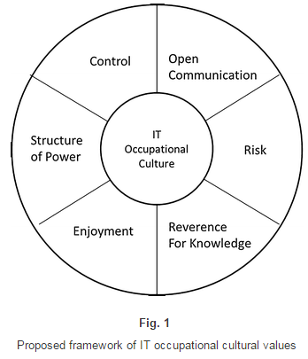

4. Methodology

The methodological approach was an exploratory empirical examination of how to measure the dimensions of IT occupational culture with both qualitative and quantitative elements. The research design was constructed similarly to other successful values scales such as House et al. [24] and Smith et al. [45]. Creating the dimensions began with a thorough literature review as shown above. As stated in Smith et al. [45], the goal of identifying dimensions for measurement is not to be exhaustive of every single issue but rather to be representative of the domain of interest in a parsimonious yet meaningful way.

Smith et al. [45] outline three distinct stages for instrument creation. Stage one include the following three steps: (1) specifying the domain and dimensionality of the constructs of interest based on the literature review, (2) generating a sample of items based on literature, interviews with IT professionals, and previously validated instruments, and (3) assessing the content validity. Content validity refers to how consistent and representative the items are with the domain on the scale construct [45, 50].

Step 1 of stage one was addressed through the thorough literature review of relevant culture studies in IS. Step 2 of stage one was addressed through both the literature review and the use of pre-survey interviews with IT professionals. This process was iterative in the sense that dimensions, definitions, and items were added and/or modified as appropriate based on feedback during the interviews. Interviewees were selected based on targeted sampling in order to obtain variation in background (age, gender, years of experience, type of experience, IT role). Experts are frequently used to validate the choice of dimensions prior to measurement [45].

In order to improve the reliability of the interviewing process, the interview questions were open-ended, rather than only focusing on the initial a priori dimensions proposed above. Interviews were audio-recorded, transcribed completely, and the transcripts shared with the interviewees identifying themes that were highlighted in the discussion in order to ensure the interviewees concurred. These steps increase the reliability of data gathered in an interview process [59]. Seven interviewees were selected who met the criteria of (1) IT professionals who have at least 7 years of work experience, (2) experience working in multiple organizations in an IT role, and (3) not members of IT management. It has previously been found that IT managers tend to share more in common with business management culture and overall organizational culture than with IT occupational culture [20, 25]. Examples of interview questions are included in “Appendix”.

Content validity in step 3 of stage one was specifically addressed by following a Q-Sort method with four PhD students to rank the items that were determined in step 2. A Q-sort is a process where the subjects rank-order the Q-sample stimuli along a continuum defined by a condition of instruction [32]. The condition of instruction included an explanation of the six dimensions but did not indicate which items went with which dimension. Students were asked to assign each item to a dimension and then rank-order their assignments based on how relevant they thought the item was to the dimension. A Q-sort can be useful in evaluating cultural dimension items with PhD students in order to determine the most appropriate items for a set of a priori dimensions [24]. Items that were not consistently assigned to the expected dimension or that were ranked low were discarded.

Stage two of the research design included finalizing the instrument items and doing a final pre-test with PhD students and faculty to ensure items were well-worded. All instrument items used a 5-point Likert scale. The last step was administering the instrument to a sample of IT personnel in different organizations. The survey instrument was sent to two different groups. Group 1 was the entire IT department for a public university in the Southeast of the US Selecting an entire IT department for comparison was necessary in order to ensure that a wide range of IT jobs (including system administrators, web developers, programmers, technical support) were included and not just one specific workgroup such as help desk employees. The University IT department was selected because CIO sponsorship of the project was able to be obtained. Group 2 was made up of members of The Association of Information Technology Professionals (AITP) on the social networking site Linked-In. AITP is a professional association of IT employees and employers representing an extremely broad range of IT roles, firm sizes, and industries.

Exploratory factor analysis was performed on the results to ensure that items were loading on the instrument dimensions appropriately. Differences in dimensional mean scores were then analyzed to see if there were statistically significant differences between the two groups of IT professionals. This choice of methodology serves to answer the research question in an unconventional way, but the core argument is this: Let us assume that there is no such thing as IT occupational culture. If this were the case, then responses from one group would be significantly different from the other. Organizational culture would most likely account for any variation in responses. However, if this is not the case, and no significant differences are found, then there must be some kind of occupational culture that accounts for the similarities in responses. In other words, the two groups must be part of the same overarching occupational group. Such a finding would be a successful first step in teasing out what the common elements of ITOC really are and would answer the research question of interest.

5. Results

5.1 Demogrsaphics

The initial qualitative interviews included seven IT professionals ranging in age from 32 to 55 with IT work experience from 11 to 22 years including a variety of IT roles as shown in Table 1. The seven interviews helped to validate the dimensions in the survey.

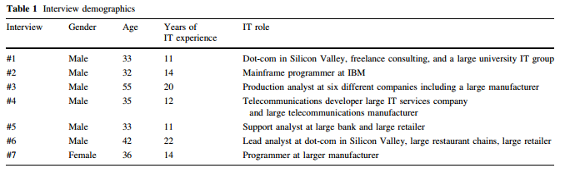

The total number of responses to the survey was 85. Six responses were removed due to being incomplete (where less than 50 % of the survey questions were answered), leaving a total usable sample size of 79 (25 for the first group of University IT staff and 54 for the second group of Linked-In IT professionals. The characteristics of all respondents were 70 % males with an average of 4.4 years of experience working in IT. Age brackets included 18–25 year olds (2), 26–35 year olds (21), 36–45 year olds (25), 46–55 year olds (22), 56–65 year olds (6), and over 65 (1). Education brackets included High School Diploma (2), Some Years of College (25), Bachelor Degree (36), and Masters Degree or higher (14). Demographic detail (for those respondents who chose to provide such) are shown in Table 2. There was a wide range of job titles for the Linked-In group including consultants, database specialists, developers, help desk workers, programmers, server administrators, network administrators, production analysts, software engineers, project managers, and technical support personnel.

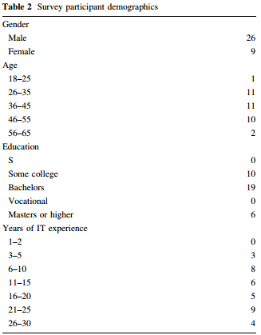

5.2 Ranking of the values

The initial interviews with IT professionals voiced strong support for all six dimensions of communication, control, risk, structure of power, reverence of knowledge, and enjoyment. The latter two dimensions were added as a direct result of these interviews. The interview data also validates that while some of the organizational dimensions used in the literature on culture in IT are relevant, not all necessarily apply to IT occupational culture, such as Plisken et al.’s [37] Performance orientation and Reward orientation. These dimensions are important to some degree to IT professionals, especially with regard to career advancement, but may not be specific to the IT occupation. Overall, the interviews provide a level of support for the idea that the SCORRE values are relevant dimensions that are specific to IT occupational culture. Table 3 shows the overall coding frequency of the SCORRE values in the interviews while Table 4 shows the mean ranking of the SCORRE values in the survey for comparison.

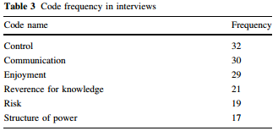

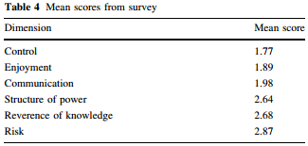

The dimension of Structure of Power is a complex issue but the interviewees has a strong preference for decentralized power structures, typically represented by flatter hierarchies in organizations with “fewer chiefs, more Indians” (#6). The interviewees gave many examples of wanting to be more empowered for independent decision making rather than having to rely on a centralized authority such as a manager or director. More diffuse power structures also meant a kind of egalitarianism: “What you say and what you decide has to be as important and as vital as much as anyone else out there.” (#3) There is a tension between IT people wanting to be in control (see below) but simultaneously wanting to empower end-users so that they are not a road block to getting things done in the organization. The survey participants ranked this dimension with a mean of 2.64 on a 1–5 Likert scale where 1 was “Strongly agree” with preferences for flatness, less hierarchy, and more decentralization of power.

The dimension of Control received the strongest support (in terms of frequency and emphasis) and was typically ranked first in importance by the interviewees. Interviewees talked about the importance of standardization, documentation, and formal control of work processes. “I think IT people have a propensity for control because IT is about solving problems” (#1). Attempts to circumvent IT controls are perceived to result in problems. “Everybody wants to be in control, but somebody’s got to be the gatekeeper!” (#6). Control is also perceived to be more important now than in the early days of the occupation when processes were more loosely defined. On the survey, Control also received the highest ranking (mean = 1.77 on 5 point Likert scale where 1 was “strongly agree”) which underscores the importance of this finding.

The dimension of Open Communication received the second strongest support from the interviewees closely behind Control. The importance of having a liaison who can effectively communication between IT groups and the end-user community as well as between IT groups and management was emphasized by all the interviewees. Open communication in the workplace was described as “vital” (#3), “number one” (#2) and “very important” (#7). Part of the barrier to effective communication may be linguistic, requiring “someone who is technical enough but not a coder, but also business enough, but they don’t actually work in the business, someone in between who can speak the speak of both sides and translate.” (#6) The other part of the barrier to good communication may be the introverted psychology of IT people themselves: “some IT people don’t communicate well, person to person, one on one” (#1). In the survey, Open Communication had a mean score of 1.98 indicating agreement with its importance.

The dimension of Risk was identified as an important issue by the interviewees and this was one of the areas of greatest tension for them because it is seen as an area of great difference between themselves and their customers. Individually, IT workers seem very comfortable with risk-taking because without it, there is less chance of true innovation happening: “You have to be comfortable to take the risk. I mean what’s the alternative, you don’t ever try something?” (#3) They are also comfortable adapting to new technology quickly in their personal lives: “Most of my friends in IT, they always want the latest cell phone, the latest laptop, even though oh it’s got a few bugs in it, but I’ve got the latest!” (#6) If there is a natural inclination on the part of IT workers to take risks (e.g., “I like innovating to the point where if everything starts breaking down then go back and fix. (#4)) this is met with great resistance in the workplace. “Customers don’t like to take risks” (#2) and “IT would take more risks if the business would back them”. (#6) IT workers may resent this “play it safe” attitude but recognize its importance to their business users “because they’re not selling a service, they’re selling a reliable service.” (#1) The complexity of this issue is reflected in Risk having the highest mean score on the survey of 2.87 indicating that risk taking was not valued quite as highly as the other dimensions.

The dimension of Reverence for Knowledge which emerged in the course of the interviews identifies part of the “geek” culture which is an element of IT occupational culture. For example, “There’s lots of stereotypes for the culture of geek, but ultimately I think it means being proud of your small obsession and proud of your intelligence on obscure subjects.” (#5) Interviewees were asked if the term ‘reverence’ was too strong and the typical response was ‘absolutely not’. Knowledge then, as opposed to organizational authority, is a key differentiator in terms of gaining respect within the occupation:

In non-IT groups, power is dependent on social stature. ‘I’m a manager, I’m a director, I’m an executive’. Whereas in IT, I think power is more ‘this is what I know’. I have a manager and my manager tells me what to do sometimes but I know this information and therefore all the people in my group respect and listen to what I say. And that is power. (#2).

In IT, if you get into a problem, you’re not going to go to the Director for help, you’re going to the person who has been there the longest and knows the most (#5).

I definitely want someone who is my supervisor to understand what I do. So I have a hard time with people who slide into an IT supervisor position who don’t really have an IT background. For me, I have a hard time with that. (#7)

The technical knowledge held by IT workers typically gives them sense of superiority over their business users:

there’s some ego involved when you’re on that side. You just have that little chip on your shoulder. You think you know more and that user community is sort of down a step. (#3)

I think some of it is mystery. To have the knowledge over a non-IT person. Sort of like a power. A power thing. Like “you don’t know how to do that.” I think that’s part of the culture. I think that’s part of the mystique, the feeling of superiority. (#4)

The survey respondents gave this dimension a mean score of 2.68 indicating agreement that this value is important.

The dimension of Enjoyment, like Reverence for Knowledge, emerged out of the interviews. There is a strong sense that IT workers enjoy what they do for a variety of reasons. They enjoy the challenge of solving puzzles, playing with cutting edge technology, expressing their creativity, and being allowed to have fun at work.

I really enjoyed it. It was a lot of fun. You never know what you’re going to run into… The other thing that I like about IT is there’s a lot of creativity to it. (#1)

A techno-geek is someone who likes to play with technology; someone who likes to tinker. (#4)

If I didn’t feel challenged, I wouldn’t be happy. #6

We’re pranksters and we laugh. People think we’re not working because we’re talking over the cube walls and laughing all day long but we’re actually getting tons of stuff done. (#7)

The interviewees referred to the theme of Enjoyment frequently as shown in Table 3 but interestingly, this dimension was ranked with a mean score of 1.89, second only behind Control in terms of importance for the survey respondents.

In summary, there was agreement between the qualitative and quantitative data sets that all six value dimensions are important for the IT occupation. Furthermore, both data sets ranked the issue of Control as the most important. Both agreed that Control, Communication, and Enjoyment were in the top three, in slightly different order, with Reverence for Knowledge, Risk, and Structure of Power as the next three in importance, in slightly different order. The two separate views of the proposed value dimensions serve to validate and reinforce each other.

5.3 Statistical tests

Statistical tests were conducted in SPSS in order to determine three things: (1) reliability of the instrument, (2) construct validity of the latent variables, and (3) possible norms.

5.3.1 Reliability results

All responses from both groups were combined in order to examine the reliability of the instrument items. Cronbach alphas were calculated in SPSS resulting in the values in Table 5. High Cronbach alphas show a high degree of correlation between items and should be high when measuring the same construct [50]. The final result of the analysis is high reliability scores, all of which were over the rule-of-thumb of 0.70, with the lowest being Open Communication at 0.72 as shown in Table 5.

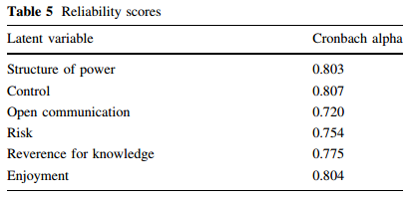

5.3.2 Construct validity

Principle component analysis (PCA) was done in SPSS to see if the items were loading on the appropriate latent variables with the number of factors constrained to six. After the initial reliability test, all the items were kept for the initial validity test. The loadings of the PCA for the rotated factor matrix (using Verimax rotation) are shown in Table 6. Construct validity is demonstrated by the correct items loading on the same constructs indicating that the instrument is measuring the right things. Moreover, there is high discriminant validity because none of the items were cross-loading on other constructs, meaning the constructs are well-defined and separate from each other. The correlation table is shown in Table 7.

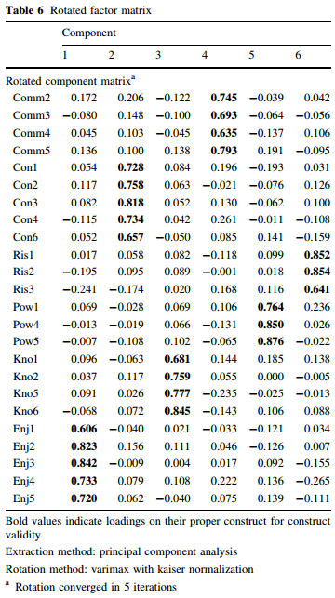

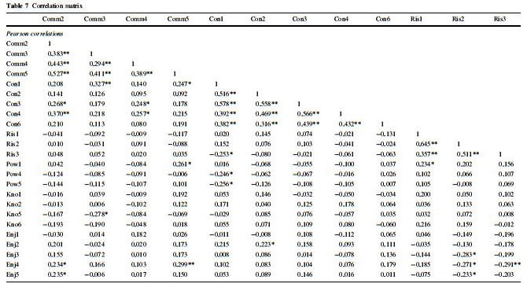
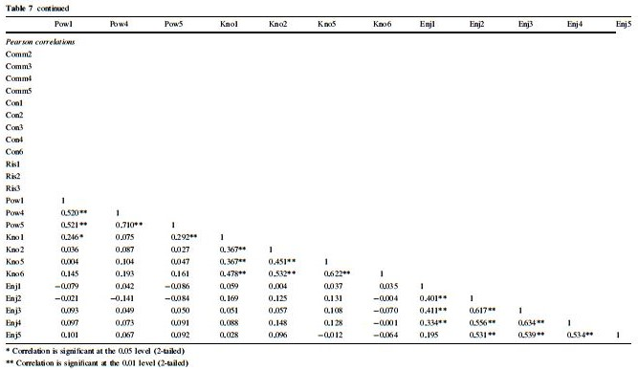

5.3.3 Norms

The final step of analysis is to look at potential norms [8]. The two groups were separated in order to see if there were any significant differences between Group 1 (all from the same organization) and Group 2 (a larger collection of IT professionals from different organizations representing the occupation broadly). Means comparisons using t tests were performed for each dimension in SPSS by group to see if there were significant differences between the groups or if they should be considered to be the same group. Descriptive statistics for the two groups are shown in Table 8. An independent samples t test was performed comparing the mean scores of each dimension by group in order to test for significant differences between the two groups. No significant differences were found. The results of the independent samples t test are shown in Table 8. The full instrument including all items is shown in the Appendix. The lack of significant differences provides evidence that the two groups are, in fact, part of the same overall occupational group. This overall IT occupational group shares a common set of cultural values where there is agreement or strong agreement that these values are important.

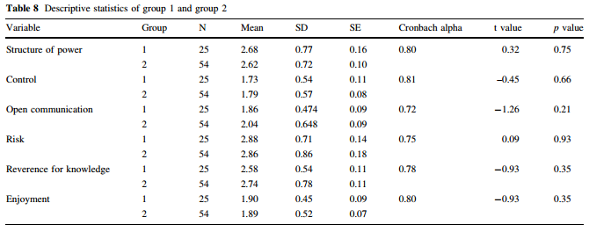

6. Discussion

The overall finding that there were no significant differences between Group 1 and Group 2 is not surprising in that it validates that these six dimensions do, in fact, reflect what is common to IT occupational culture, consistent with the integrative perspective of culture. If there had been significant differences in each dimension, this would have indicated that some of the dimensions were overlapping with organizational cultural differences. So the level of analysis here is critical for interpreting the results. Just as national culture differs between different nations while within-nation means do not vary significantly, so too occupational culture should not vary significantly within the same occupation. It is expected that one would find significant differences when comparing these dimensions with different occupations. The next step in this ongoing research is to compare and contrast IT occupational culture with business management culture. Such differences would serve to identify the areas of difference that may drive friction in IT/Business alignment.

As an example of such cultural friction, the interviews revealed that there may be an underlying tension between achieving business alignment and the SCORRE value of Reverence for Knowledge. Even though a manager with business experience may excel at getting their team aligned with business objectives, such managers do not get the respect of their IT group who values technical knowledge over business knowledge. Furthermore, the reverse may also be true, that managers with technical background who have the respect of their IT group are less able to get the group aligned with business priorities.

The other dimension that was added as a result of the interviews, Enjoyment, was a theme repeated in all the interviews and rated highly in the survey. It is important to IT professionals to enjoy what they do, have fun at work, and even feel a sense of familial connection with the people they work with. This is an important idea that contradicts the traditional stereotype of computer geeks being focused on technology over people.

It is not the intention of this research to assert that ITOC is easy to measure or to make the complex realm of culture deceptively simple. Snowden and Boone [47] assert that there is a danger to managers who misread a complex environment and assume that their traditional decision-making style is the best one for every context. The intent of this initial study, however, was merely to identify the core elements of IT occupational culture and to that end, this study has so far been successful through its qualitative and quantitative results. The finding of no significant differences between Group 1 and Group 2 simply means that Group 1 (the university IT department) appears to be a typical instance of the IT occupation when compared to the industry norm of Group 2. That said, there is value in the results for business leaders.
If there is a cultural chasm between IT professionals and non-IT business managers, it is likely that this is primarily due to differences in occupational cultures with differing values. Business leaders typically place emphasis on very different values from the SCORRE values. For example, Posner and Schmidt [38] have used a set of values in a series of studies every decade for the past 30 years in order to identify changes in business management values over time. These are Organizational effectiveness, High morale, Organizational reputation, Organizational efficiency, High productivity, Organizational stability, Organizational growth, Organizational value to the community, Profit maximization, and Service to the public [38]. Business managers who assume that IT employees have the same values at work will only contribute to this cultural divide.

However, some scholars such as Argyris [1] assert that organizational dysfunction is not the result of culture, but rather the culture is a by-product of the behavior of individuals in the organization. Thus, differences in culture are the result not the cause of dysfunction. Despite this chicken-or-egg dilemma, it is still useful to examine the aggregated values of individuals that form an overall culture. There is certainly a reciprocal relationship between individuals and culture, each impacting the other. Smith [46] emphasizes that “an accumulation of innumerable individual actions may well cause cultures to change over time. However, for any one individual, influence from culture to individual will be much more potent than the reverse.” For this reason, understanding cultural value differences is of the utmost importance.

We propose that this type of research provides meaningful practical advice to non-IT business managers (cultural outsiders) on how to recognize, reward, and motivate IT employees by a) understanding what they value and b) not violating those values. To illustrate, let us examine the opposite of each value dimension to see how this might be the case. If IT employees prefer a more decentralized structure of power, then any attempt to take away their individual decision-making ability or add additional layers of approval will be met with strong resistance. If Control is important for IT, then managers that do not insist on proper documentation, software and hardware standardization across the enterprise, and allow frequent exceptions to the rule rather than consistent enforcement of policies, then the resulting chaotic environment will violate one of IT’s values. If managers or even end-users attempt to withhold job-related information from IT personnel, this will violate the value of Open Communication. If managers insist on punishing mistakes and create a culture of fear then this would violate the value of Risk. The last two are perhaps especially important. If managers do not recognize the internal totem pole of knowledge experts on an IT team and fail to recognize and reward those who contribute to effective knowledge sharing, they will be violating the core value of Reverence for Knowledge. This can potentially have the negative effect of leading to knowledge hoarding, not knowledge sharing. Furthermore, managers that do not come up through the technical ranks will not (initially) have the respect of their IT employees and must gain respect by focusing on the other values as well as demonstrating deference to the technical expertise of their staff. Finally, managers that do not offer their IT employees challenging work in a playful atmosphere, in opposition to Enjoyment, will most likely experience employee retention issues over time. Being able to quantitatively measure these value dimensions can make a potential difference for organizations.

In short, we have thus far been able to address the first of Straub’s [50] three validities for survey-based research, namely instrument validity as demonstrated above. The second type of validity, internal validity, is maintained by being aware of other rival explanations. For example, one might expect there to be no significant differences between the university group and the industry group if the dimensions were trivial and were of no real interest to IT professionals. However, the initial interviews assert that the six SCORRE dimensions capture many of the core themes that are important. The third form of validity, statistical conclusion validity, will be addressed as the sample size increases as part of this ongoing research stream.

Even though generalizability will increase as the sample size increases, there is already a high level of generalizability, even at this early stage of research, due to the responses of the university group being so close to the responses of the industry group. Moreover, the findings may be generalizable across different roles within IT since respondents included different roles such as systems administration, software development, and support operations.

7. Future research

This preliminary study is part of a larger research project and provides the foundation for further exploration. The next planned steps will include (1) comparing the responses of IT professionals to those of business managers to look for significant differences and (2) examining the impact of occupational cultural differences of IT/Business Alignment and organizational outcomes. Furthermore, we do expect to modify and refine the instrument as we conduct further interviews and surveys. Beyond the full study, there are more areas to uncover. Which dimensions can be influenced by managers and how exactly can they influence them? What are the differences in IT occupational culture between IT workers in different national cultures? What are the differences within IT occupational culture between different types of IT roles? Are there consistent personality traits or profiles that have helped to form ITOC over time? Finally, looking beyond values and beliefs to the other aspects of culture, what are the rites and rituals of IT occupational culture that lead to group cohesion and career success? Examples of rites and rituals that are specific to IT occupational culture might include on-call duty, technical certification, afterhours gaming and LAN parties, and industry recognition.

8. Limitations and Key Assumptions

The first limitation of the study is an objection noted in Schein [42] that organizational culture can only be measured with qualitative methods such as ethnography and case study with extended periods of time in an organization rather than quantitative methods. This objection may be mitigated because initial qualitative studies have been successful in identifying the initial components of IT occupational culture for further quantitative (survey-based) investigation. Furthermore, Hofstede [21], House et al. [24], and Iivari and Huisman [25] have already demonstrated the viability of the survey method in studying culture. There is a tradeoff in research methods between breadth and depth. Because the initial qualitative research has been done to obtain rich examples from interviews, the risk of not measuring the right things (construct validity) is lessened. Furthermore, what the quantitative approach lacks in richness, it gains in measurability, which is the stated research objective. The key assumption of this research is that IT occupational culture can be measured. A second limitation is that generalizability is restricted to a US population of IT professionals. Views on occupational values may change between national cultures [18]. A third limitation is the possibility of test bias in the instrument. Finding no mean differences between groups could mean that the two groups are part of the same overall cultural group, but it could also potentially be explained as an error in the measuring instrument not being granular enough to detect differences. This last limitation will be addressed with the next phase of research that compares non-IT employees with IT employees where IT employees are expected to rate the SCORRE values significantly higher than non-IT employees.

9. Contributions to knowledge

There are several important contributions from this preliminary research. The dimensions and instrument are the primary contributions for researchers. No empirical measurements have thus-far been attempted specifically on IT occupational culture. This study answers the call that “research is needed that seeks to operationalize IT values, to discover which values in fact are most appropriate to consider, as well as to discover how values might cluster together to form some higher order constructs of IT culture.” [24, p. 371] Furthermore, Kaarst-Brown and Robey [27] suggest that understanding IT culture better will assist managers in recognizing the difficulties of implementing change in the organization, something that firms still wrestle with today. A better understanding of IT occupational culture will have the practical value of (1) facilitating smoother interactions between IT and business (and other departments within an organization), (2) helping managers better understand resistance to change within the organization and (3) leading to better understanding the cultural determinants of IT success. The Discussion section identified specific ways in which managers can benefit from understanding ITOC values including specific actions to take as well as those to avoid. Another important contribution for practice is the evidence that the SCORRE values are common across the IT occupation. Therefore, the ability to understand and manage them is a transferable skillset that should prove useful to business leaders as they move through their careers from one firm to another.

10. Conclusion

An instrument was created to measure the dimensions of IT occupational culture. Based on the literature and in-depth interviews with IT professionals, these six dimensions include Structure of Power, Control, Open Communication, Risk, Reverence for Knowledge, and Enjoyment (i.e., SCORRE). A study was conducted with 79 IT professionals to test the new instrument. The sample was divided into two groups, one group from the same IT organization and a larger group representing IT occupational norms. It was found that there were no statistically significant differences in the mean responses of these two groups, adding further evidence to the belief that SCORRE represents many core values that form the foundation of IT occupational culture. The instrument was found to have both high reliability and construct validity and is ready for further use in our ongoing research. In our research program, this initial instrument will go through further refinement based on extensive field work, larger organizational samples, and both qualitative and quantitative analyses.

Appendix

See Tables 9 and 10.

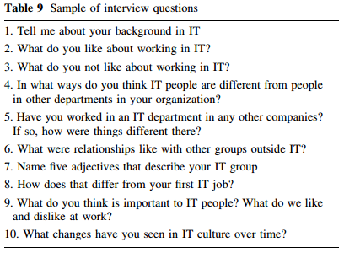

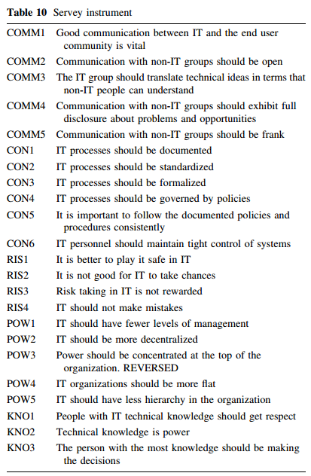

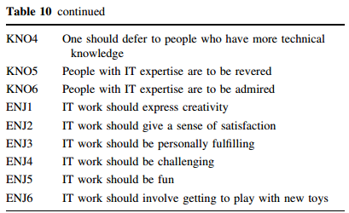

References

1. Argyris C (2010) Organizational traps: leadership, culture, organizational design. Oxford University Press, New York

2. Ashkanasy N, Broadfoot L, Falkus S (2000) Questionnaire measures of organizational culture. In: Ashkanasy N, Wilderom C, Peterson M (eds) Handbook of organizational culture and climate. Sage Publications, Thousand Oaks

3. Bagchi K, Hart P, Peterson M (2004) IT product adoption and the influence of national culture. J Global Inf Technol Manag 7(4):29–46

4. Bagchi K, Kirs P (2009) The impact of Schwartz’s cultural value types on ICT use: a multi-national individual-level analysis. In: Proceedings ICIS 2009, Phoenix, Arizona

5. Brief A, Nord W (eds) (1990) Meanings of occupational work. Lexington Books, Lexington

6. Caillois R (1961) Man, play and games (trans: by Barash M). University of Illinois Press, Chicago

7. Choden K, Bagchi K, Udo G, Kirs P (2010) Do Schwartz’s values matter in internet use of individuals in developing and developed nations? In: Proceedings 2010 AMCIS, Lima

8. Churchill G (1979) A paradigm for developing better measures of marketing constructs. J Market Res 16:64–73

9. Cooper R (1994) The inertial impact of culture on IT implementation. Inf Manag 27(1):17–31

10. Deal T, Kennedy A (1982) Corporate cultures: the rites and rituals of corporate life. Addison-Wesley, Reading

11. Dellana S, Hauser R (1999) Toward defining the quality culture. Eng Manag J 11:11–20

12. Duliba K, Baroudi J (1991) IS personnel: do they form an occupational community? ACM CPR 13(2):111–118

13. Dube´ L, Robey D (1999) Software stories: three cultural perspectives on the organizational practices of software development. Account Manag Inf Technol 9:223–259

14. Ferrante J (2003) Sociology: a global perspective. Wadsworth/ Thomason Learning, Belmont

15. Gallivan M, Srite M (2005) Information technology and culture: identifying fragmentary and holistic perspectives of culture. Inf Organ 15:295–338

16. Greenwood E (1957) Attributes of a profession. Soc Work 2:45–55

17. Guzman I (2006) As you like I.T.’: occupational culture and commitment of new information technologists. Unpublished dissertation

18. Guzman I, Joseph D, Papamichail K, Stanton J (2007) RIP— beliefs about it culture: exploring national and gender differences. SIGMIS-CPR 2007

19. Guzman I, Stanton J (2004) Culture clash! The adverse effects of IT occupational subculture on formative work experiences of IT students. Americas conference on information systems, 2004

20. Guzman I, Stanton J, Stam K, Vijayasri V, Yamodo I, Zakaria N, Caldera C (2004) A qualitative study of the occupational subculture of information systems employees in organizations. SIGMIS 2004, Tucson, Arizona

21. Hofstede G (1980) Cultural consequences: international differences in work related values. Sage, Beverly Hills

22. Hofstede G, Neuijen B, Ohayv D, Sanders G (1990) Measuring organization cultures: a qualitative and quantitative study across twenty cases. Adm Sci Quart 35:286–316

23. Hofstede G, Hofstede J (2005) Cultures and organizations: software of the mind. McGraw-Hill, New York

24. House R, Hanges P, Javidan M, Dorfman P, Gupta V (2004) Culture, leadership, and organizations. Sage publications, Thousand Oaks

25. Iivari J, Huisman M (2007) The relationship between organizational culture and the deployment of systems development methodologies. MIS Quart 31(1):35–58

26. Johnson S, Koh H, Killough L (2009) Organizational and occupational culture and the perception of managerial accounting terms: an exploratory study using perceptual mapping techniques. Contemp Manag Res 5(4):317–342

27. Kaarst-Brown ML, Robey D (1999) More on myth, magic and metaphor: cultural insights into the management of information technology in organizations. Inf Technol People 12(2):192–217

28. Kappos A, Rivard S (2008) A three-perspective model of culture, information systems, and their development and use. MIS Quart 32(3):601–634

29. Karahanna E, Evaristo J, Srite M (2005) Levels of culture and individual behavior: an integrative perspective. J Global Inf Manag 13(2):1–20

30. Leidner D, Kayworth T (2006) A review of culture in information systems research: toward a theory of information technology culture conflict. MIS Quart 30(2):357–399

31. Markus M, Bjorn-Andersen N (1987) Power over users: its exercise by system professionals. Commun ACM 30(6):498–504

32. McKeown B, Thomas D (1988) Q Methodology. SAGE Publications, Newbury Park

33. Montano B, Dillon R (2005) The impact of technology on relationships within organizations. Inf Technol Manag 6:227–251

34. Nord J, Nord G, Cormack S, Cater-Steel A (2007) IT culture: its impact on communication and work relationships in business. Int J Intercult Inf Manag 1(1):85–107

35. Orlikowski W (1991) Integrated information environment or matrix of control? The contradictory implications of information technology. Account Manag Inf Technol 1(1):9–42

36. Orlikowski W, Baroudi J (1989) The information systems profession: myth or reality? Office Technol People 4:13–30

37. Pliskin N, Romm T, Lee A, Weber Y (1993) Presumed versus actual organizational culture; managerial implications for implementation of information systems. Comput J 36(2):143–152

38. Posner B, Schmidt W (1996) The values of business and federal government executives: more different than alike. Public Personnel Manag 25(3):277–289

39. Quinn R, Rohrbaugh J (1983) A spatial model of effectiveness criteria: toward a competing values approach to organizational analysis. Manag Sci 29:363–377

40. Ramachandran S, Rao SV (2006) An effort towards identifying occupational culture among information systems professionals. In: Proceedings of the 2006 ACM SIGMIS CPR conference on computer personnel research: forty four years of computer personnel research: achievements, challenges & the future (SIGMIS CPR '06), ACM, New York, NY, pp 198–204

41. Romm T, Pliskin N, Weber Y, Lee A (1991) Identifying organizational culture clash in MIS implementation. Inf Manag 21:99–109

42. Schein E (1985) Organizational culture and leadership. Jossey-Bass Publishers, San Francsico

43. Schein E (1999) The corporate culture survival guide. Jossey-Bass Publishers, San Francisco

44. Scholz C (1990) The Symbolic Value of Computerized Information Systems”. In: Gagliardi P (ed) Symbols and artifacts: views of the corporate landscape. Aldine de Gruyter, New York

45. Smith H, Milberg S, Burke S (1996) Information privacy: measuring individuals’ concerns about organizational practices. MIS Quart 20(2):167–196

46. Smith P, Dugan S, Trompenaars F (1996) National culture and the values of organizational employees: a dimensional analysis across 43 nations. J Cross Cult Psychol 27(2):231–264

47. Snowden DJ, Boone ME (2007) A leader’s framework for decision making. Harv Bus Rev 85(11):68–76

48. Spillman L (2002) Introduction: culture and cultural sociology. In: Spillman L (ed) Cultural Sociology. Blackwell Publishers, Oxford

49. Srite M, Karahanna E (2006) The role of espoused national cultural values in technology acceptance. MIS Quart 30(3):679–704

50. Straub D (1989) Validating instruments in MIS research. MIS Quart 13(2):147–169

51. Swidler A (1986) Culture in action: symbols and strategies. Am Sociol Rev 51(2):273–286

52. Tafti A, Mithas S, Krishnan M (2007) Information technology and the autonomy-control duality: toward a theory. Inf Technol Manag 8:147–166

53. Trice H (1993) Occupational subcultures in the workplace. ILR Press, Ithaca

54. Von Meier A (1999) Occupational cultures as a challenge to technological innovation. IEEE Trans Eng Manag 46(1):101–114

55. Walsh I (2009) Development of an instrument to assess individual it culture. In: Proceedings of the Fifteenth Americas conference on information systems, San Francisco, August 6–9th 2009

56. Walsh I, Kefi H (2008) The spinning top model, a new path to conceptualize culture and values: applications to IS research. Twenty Ninth International conference on information systems, Paris 2008

57. Ward J, Peppard J (1996) Reconciling the IT/business relationship: a troubled marriage in need of guidance. Strateg Inf Syst 5(2):37–65

58. Webster J, Martocchio J (1992) Microcomputer playfulness: development of a measure with workplace implications. MIS Quart 16(2):201–226

59. Yin R (2003) Case study research: designs and methods. Sage Publications, Thousand Oaks

